**WORK SHEET Class: V**

Name of Student:…………………………………. **ACROSS THE WALL**

1. Fill in the blanks
2. Bachukhan used …………………………….. children to play.
3. ……………………………between the members is the strength of a team.
4. Ranking and …………………competition should be avoided amongst players.
5. If a child plays or …………..at the school level with full devotion that should be the real……
6. Name three sports that are played as a team.

………………………………………………………………….

1. Find out the national game of the following countries

1. India: …………………………..

2. America: ……………………………………………………

3. Australia: ………………………

4. England: ………………..

1. Identify the pictures of some famous Indian sports women

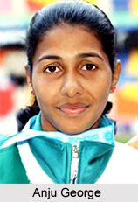…………………………… ………………………………

………………………..………………………………..

1. Answer the following
2. What is the strength of a team?

………………………………………………………………………………………………………………

1. With what spirit should a person play a game?

………………………………………………………………………………………………………

1. What is the difference between playing for yourself and for the team.

………………………………………………………………………………………………………………

1. Name some
2. individual sports

…………………………… ………………………… …………………………………..

1. sports men

………………………….. ………………………… …………………………………..

1. out door games

………………………….. …………………………. …………………………………….

1. In door games

-------------------------- -------------------------- ------------------------------